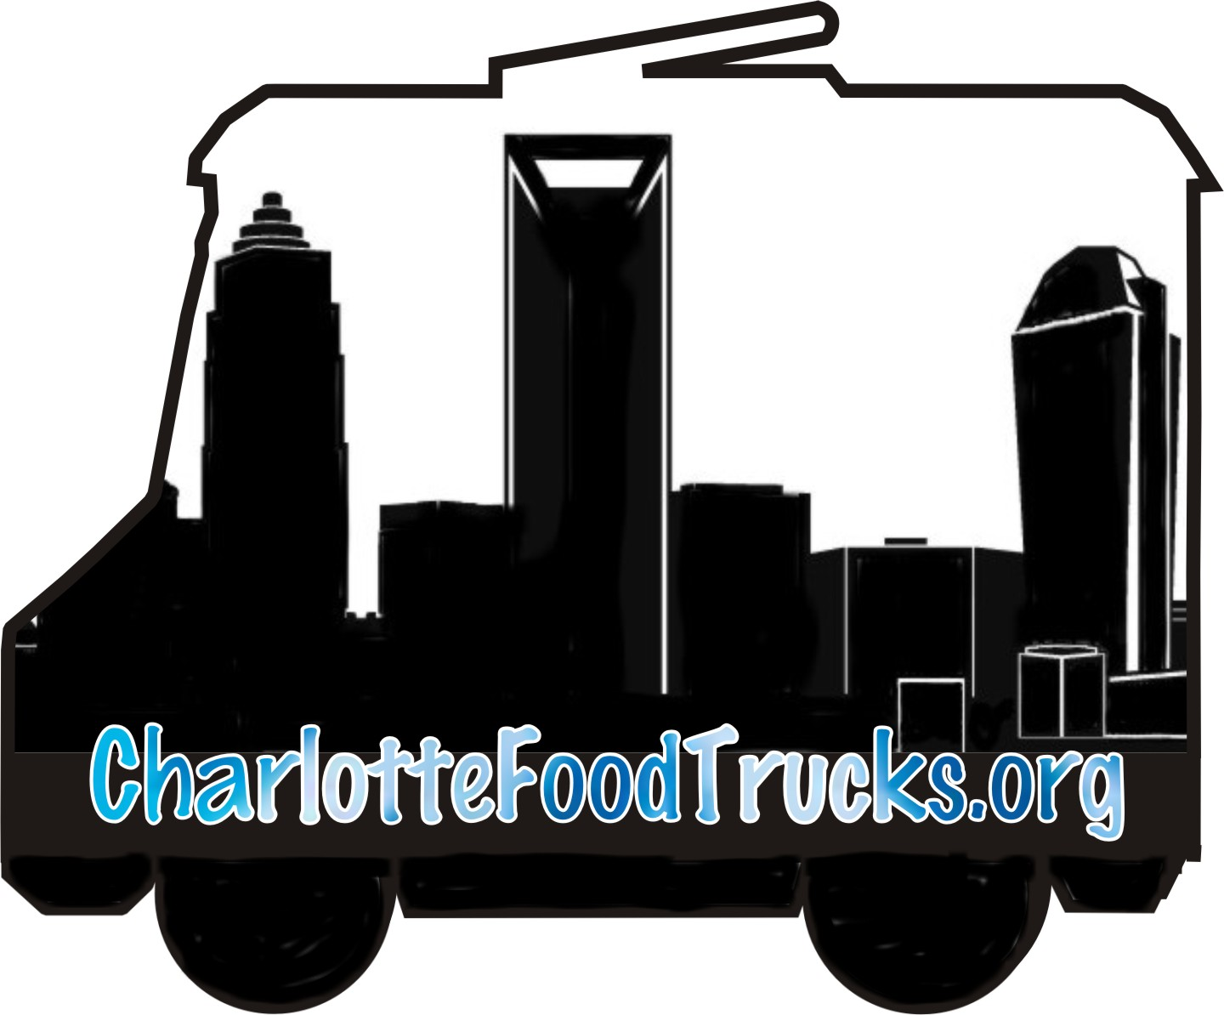

COMPLETE THIS FORM TO RECEIVE BOOKING INFORMATION FROM CHARLOTTE FOOD TRUCK ASSOCIATION TRUCKS

Name:

Email:

Phone:

Date of Event:

Hours: From _______ to _______

Number of Guests:

Who is responsible for payment? ___ Event planner ___ Each individual guest

Event Location:

This location is a _____private or _____public location. (It is your responsibility to secure any necessary permits or permissions. Food trucks will be unable to accept jobs which would require parking in areas that are not zoned to allow them.) Please see the attached page for more information regarding food truck placement on private properties in Charlotte.

Type of Event:

_____ Private Party (birthday, anniversary, etc.)
_____ Corporate Event
Company:
_____ Employee or Customer Appreciation Event
_____ Neighborhood Event
_____ Charity Event
_____ Other
Please describe:

Type and Number of Truck(s) Needed: _____savory truck(s) _____dessert truck(s)
How many food trucks do you need? Please visit http://charlottefoodtrucks.org/index.html and download the Wondering how many trucks you need for your event? Check out these guidelines file.

Email the completed form to webmaster@charlottefoodtrucks.org and someone will be in touch. Thank you for supporting Charlotte's entrepreneurial food truck community!

New laws were enacted in March 2017 for the City of Charlotte regarding placing food trucks on private property. A link to the city's information can be found on the 'Find A Truck' page of the CharlotteFoodTrucks.org website.

It is now the responsibility of the property owner, not the truck, to be sure the location is in compliance with these laws. A permit will be required, and if you're booking four or more trucks at once, a site inspection and approval will be needed as well. The permit is valid for multiple events through one year.

Remember, these laws are for those properties in the City of Charlotte only. They also only apply if each food truck customer will be paying their own bill. If the host is paying for the entire bill, it is a catering situation and the permit requirement does not apply.

If you are looking to hire a truck to sell directly to your guests--in other words, if you are NOT paying the bill--and you are located within Charlotte city limits and planning to hold your event on private property, you will need to apply for a permit. It takes approximately two weeks to receive a permit, so allow enough time to have the permit in place before your event or you will be subject to a fine.

If you are not sure if you fall within the city's boundaries, you will find a link and instructions on how to determine this information on both the 'Find A Truck' and 'Hire A Truck' pages of the CharlotteFoodTrucks.org website.

Exception: If you are a church, school, or residential area, the permit you need is a Zoning Use Permit. The Zoning Use Permit is good for a one-time event, and you may receive up to 10 a year. (Each one is a separate purchase; as of August 2017, the price is $175.00.) You would also need to show that the owner approves holding the event on their property; this would involve filing a notarized Ownership Verification Form.

